**Call Center Clustering**

**Rohan Salvi, Sanket, Shirse, Shubham Asabe, Vipul Ahire, Prof. Manisha Bharati**

***Department of Computer Engineering, Indira College of Engineering and Management, Parandwadi, Pune***

***Abstract:***

*This work presents a study related to the methods of text mining applications, more specifically, data clustering, in call center’s databases, whose texts are in the Portuguese language. The main objective is to identify new and useful knowledge, based on customers’ claims. Through the information agreement, it will be possible to identify better ways to help the customer, increasing their satisfaction with company services as well as supplying the call center staff and other related areas with a set of procedures and information concerning the most common customer’s questions.*

**Keywords:*Text Mining, Clustering, Call Center, Speech To Text***

**1.INTRODUCTION**

Many companies who give telephonic attendance services for its customers need solutions guided to the information technology that make possible the register of their customer’s contacts, the aid and support to the attendants. For such, new access technologies to the knowledge bases and flow of information management can increase the productivity of the attendants and, as consequence, improve the quality of the given services. Many times, the attendance can be made by the Internet, bringing some advantages such as: costs reduction with attendance, user satisfaction increasing and knowledge of the customer’s interests, gotten through the automatic storage of the typed information. Text mining tools directed to knowledge bases creation, support and operation, and for attendance centers are applicable for the Web cases email or telephone attendance. The technologies presented in these tools make possible to create knowledge bases for queries through the search of one or more words in documents, allow to combine resources of search in texts with resources of interaction with support (attendance it the Web: email, chats, virtual rooms, etc), and make possible the creation of knowledge bases for queries in natural language. Thus, the objective of this work is to show some methods of text mining applied in call center’s databases, especially in customers’ complaints of a electrical energy company, where the results serve to show that techniques are extremely useful during the company services evaluation processes, as also to be used in decision taking. For this, a text mining tool called Insight Discoverer Clustered by Temis was used, that contains the documents grouping functionality or *clustering*, allowing the classification of the same ones. With this study we have created conditions that can to evidence problems that are occurring with frequency, as for example problems of invoicing, financial income, supply and attendance quality, etc, who are gotten by the analysis of the results.

# Methodology

**Proposed System:**

In this System Customer Request in Text Format to Service Call Center for classify the Request into different categories listed below:

1. New vehicle purchase enquiries (i.e., Enquiry on latest or future or existing product features, price, availability, closest showroom to drop in for purchase or exchange, etc.)

2. Test drive requests (i.e., Request for booking test drives, follow up Request with customers to schedule the same, confirmation that test drive has been done as per schedule or with delayed schedule, etc.)

3. Breakdown (i.e., Customer Send Request TO contact center to report vehicle break down and providing his location details for repair or breakdown assistance, Road assistance mechanic reaching out to customer and reaching location with preliminary input on vehicle condition)

4. Feedback (Feedback collected post sales /service on vehicle delivery on customer sales/ service experience)

5. Vehicle Quality (Complaints of the vehicle parts not functioning properly, repetitive complaints, etc. - except breakdowns and failures

**B) System Design:**

This section explains the steps involved in building the tool. This section explains step involved in tool it begins with customer request speech in form of text or voice if customer request in voice then it will converted into text then stop words or unused word will be eliminated then the request will be classified according to query department type then this query will be resolved by the respective department and will be updated in customers end as well as organizations end

## Flow of work

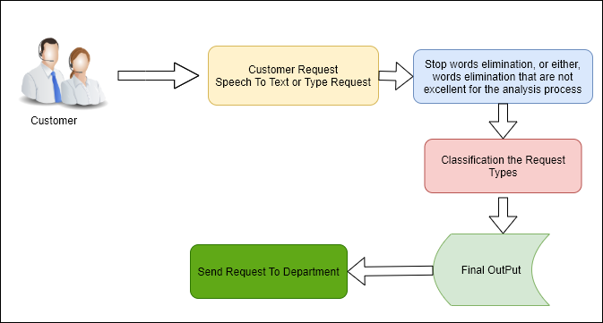

# Results

**4.Conclusion**

The performance of the tool and the quality of the obtained results was improved using a specific cartridge to Portuguese language. This facility contains particular properties that are very helpful. In accordance with the obtained results, it must be stressed that the sample of data, as well as the activities carried through the pre-processing step and clustering process are of fundamental importance to the knowledge extraction. In our experiments the traditional categorization process built during the company practice was confirmed and could be validated. Although promising results have been achieved in this work, there are some issues that can be further investigated by the call center experts. But we can conclude that now is possible to implement an automatic classification system to online monitor the service quality. Finally, it can be concluded that the obtained text mining results can be used in the power electric industry to: Understand the needs of customers while accessing preferred customers.

**5.References**

*1. Multiclass Digital Audio Segmentation with MFCC Features using Naive Bayes and SVM Classifiers(2019)(ASYU)*

*2. Analysis of Detected Silent Segments in Call Center Recordings(2019)(IDAP)*

*3. Feature Selection for Anomaly Detection in Call Center Data(2019) (ELECO)*

*4. Text clustering algorithm based on deep representation learning(2018 )(The Journal of Engineering)*

*5. Artificial Neural Networks in Customer Segmentation(2019)(SIU)*

*6. Mobile Phone Clustering From Speech Recordings Using Deep Representation and Spectral Clustering(2018)*

*7. A Hybrid Approach for Mobile Phone Clustering With Speech Recordings(2019)*

*8. Machine Learning-based Silence Detection in Call Center Telephone Conversations(2019)*

*9. Classification Techniques for Automatic Speech Recognition (ASR) Algorithms used with Real Time Speech Translation (2017)*

10. A Review on Emotion Recognition using Speech(2017)